**Rube Goldberg Machine**

**Web Quest for Physics**

**Energy Transfer and Simple Machines November Project**

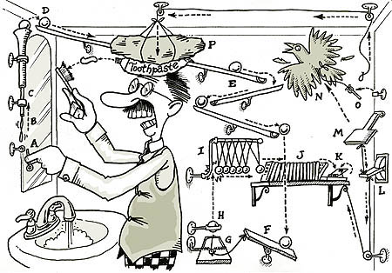  
  
**Introduction**  
Rube Goldberg was a cartoonist famous for creating diagrams that showed an extremely complicated, complex way to accomplish simple, ordinary tasks. You, too, will follow in the creative footsteps of Mr. Goldberg on the path to simple machine invention.  
  
**Task**  
You will design and build a working Rube Goldberg machine, a very complicated machine to perform a simple everyday task. You will keep a journal of your progress.   
  
**Process**

1. Review sample Rube Goldberg cartoons at the [Official Rube Goldberg](http://www.rube-goldberg.com/) site and the [Rube Goldberg Gallery](http://www.rubegoldberg.com/html/gallery.htm)
2. Review the proponents of simple machines at these sites:

* [Simple Machines](http://sln.fi.edu/qa97/spotlight3/spotlight3.html)
* [Six simple machines](http://www.coe.uh.edu/archive/science/science_lessons/scienceles1/finalhome.htm) and online quiz
* [Elements of Machines](http://www.mos.org/sln/Leonardo/InventorsToolbox.html)
* [Simple Machines Glossary](http://edheads.org/activities/simple-machines/sm-glossary.htm)

3. Review these sites for information on transfer of energy:

* [Types of Energy](http://www.factmonster.com/ipka/A0907040.html)
* [Energy](http://id.mind.net/%7Ezona/mstm/physics/mechanics/energy/energy.html)
* [Energy Changes](http://www.ftexploring.com/energy/energy-1.htm)

4. Try these suggested sites for other ideas for your project:

* [How Stuff Works](http://www.howstuffworks.com/)
* [Rube Goldberg Machine Contest](http://www.purdue.edu/newsroom/rubegoldberg/index.html)
* <http://www.youtube.com/watch?v=l8Oes7Ze-Rg&feature=related>

5. Keep a journal as you progress through this project. This should include at least 5 entries. Entry examples: My thoughts about this project; Responses to my research; Brainstorm of my Rube Goldberg ideas; Planning stages; Diagram of my System; Materials needed; Building process; First attempt; Final thoughts and What I would do differently or the same next time.   
  
6. Draw a labeled diagram of your machine with detailed instructions of your steps.  
  
7. After assembling the materials, now build your Rube Goldberg machine including the following guidelines:

* machine must perform some task, any task within reason.
* must have at least 5 steps. 10 or more will earn bonus points.
* must include at least 3 simple machines (levers, pulleys, etc.). If you use all 6, five bonus points are earned.
* must use 3 energy transfers
  + This site has an elaborate example of energy transfers: <http://www.cs.cmu.edu/afs/cs.cmu.edu/academic/class/16311/www/current/hw/examples/hw2.htm>
* must be free standing and able to get through the door
* must be able to complete the task more than once
* cannot touch machine after it starts
* no electrical devices allowed

8. You will demonstrate your machine in a class exhibition at the end of the month.   
  
9. Include in your journal that includes a final analysis/self-evaluation on how well you think you did on this project. Include:

* What did I do right?
* What did I do wrong?
* What would I change if I could?
* How could I make the project better?

**Conclusion**  
At the end of this project you will become more acquainted with simple machines and energy transfer needed to make a working machine similar to the famous Rube Goldberg cartoons.  
  
**Credits**  
Original Webquest taken from <http://www.italyhighschool.org/Rube%20Goldberg%20Machine.htm>; revised by Paula Hawks  
Clip art courtesy of [Rube Goldberg Gallery.](http://www.rubegoldberg.com/html/shop_window.htm)